COMET-Farm Step-by-Step Cropland Guide

Tasks:
- Navigate to COMET-Farm.com and Create an account
  - Navigate to www.comet-farm.com
  - Using the Navigating COMET-Farm document HERE, familiarize yourself with the COMET-Farm user interface.
  - Using the Creating a COMET-Farm Account document HERE, create a COMET-Farm account (if you have not already done so).
    - While you can use any component of COMET-Farm without creating an account, creating an account has many benefits. Review how COMET stores your project information and the benefits of creating an account HERE.
- Create new project
  - Select Tool in the upper right corner of the COMET-Farm web page.
  - Follow the instructions on Creating a New Project help document to begin your project.
    - For users new to COMET Cropland accounting, we would recommend just selecting Cropland, Pasture, Range, Orchards/Vineyards as your accounting activity. You can always add other accounting activities later.
    - Be sure to select define activities to proceed to the next task.
- Information collection:
  - Data required for COMET-Farm: parcel location, historic management (1950-2000), Current management, and your change in management for the scenario comparison.
  - Due to the layout of the interface, it may be useful to collect your management information ahead of time and simply transfer to the user interface. This can aid in data organization and also provides a simple way viewing all inputs together.
    - We do have a Cropland Data Entry Spreadsheet to assist in data collection prior to going through the user interface and outlines every data point COMET-Farm will ask for. Unfortunately, you cannot upload that spreadsheet to COMET. It is simply a tool to gather all of your management information before using the COMET-Farm interface.
- Define parcel(s)
  - COMET-Farm allows for field specific greenhouse gas (GHG) accounting. COMET defines parcels as fields that have been and will continue to be managed similarly. When entering management details on the historic, baseline, and future management pages, you are tying the management details to that specific parcel.
  - Using the navigation window that appears after you defined your accounting activity, enter the address, coordinates, or landmark to find the general area of where you intend to create a parcel.
    - You may also exit out of the window and zoom in with your mouse to manually find the location.
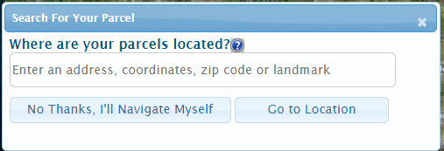
  - Adding a parcel:
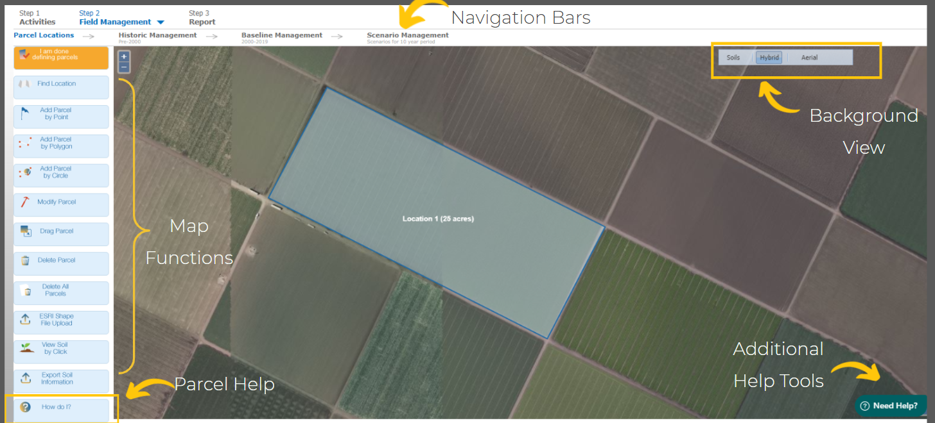
    - Using the Map Functions toolbar on the left, you may add a parcel by point, polygon, or circle. Outside of this workshop, you may also upload a shapefile. The sample project parcel was created using add parcel by polygon.
        - Point: Select add parcel by point→ using your mouse, select a central point of the parcel, name your parcel, and add the area (acres), select save location.
        - Polygon: Select add parcel by polygon→ using your mouse, click to drop each point of your polygon until you have connected all points. Name your parcel. Select save location.
        - Circle: Select add parcel by circle→ using your mouse, select a central point of the parcel, while holding down the right mouse button, drag the cursor until the circle is at the desired circumference.
        - Shapefile: Select ESRI Shapefile Upload→ browse files to locate desired shapefile, specify the unique parcel identification field, select upload. If you are having trouble uploading the shapefile, check out this video or solution article for troubleshooting.
    - Give your parcel a short (25 characters), but descriptive name. This will help later when you have multiple parcels.
    - COMET-Farm can support parcels less than 1100 acres or up to 20 smaller parcels. If you would like to use COMET-Farm to account for more than the allotted acres or number of parcels, you can always create a new project for additional parcels or reach out to the COMET-Farm Team for details on accessing the API.
    - We encourage you to use the soils button on the background view to investigate the different soil types in your defined parcel. To view more details on the soil type, select view soil by click from the pane on the left.
    - When you are done adding parcels, select the orange button, I am done defining parcels.
- Enter historic management for parcel(s)-
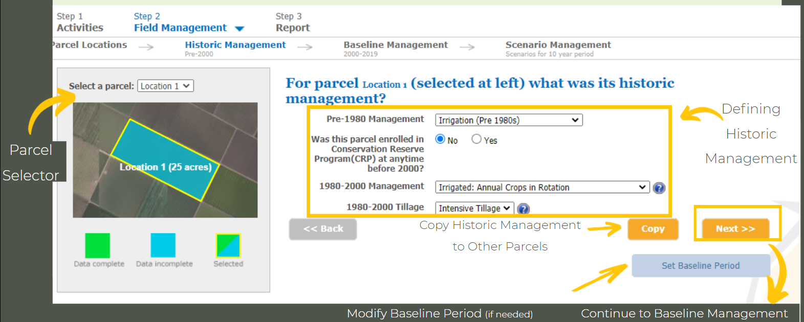
  - The historic management pane allows the COMET-Farm platform to build baseline soil carbon levels based on management before year 2000, i.e. before the baseline period.
  - If you have more than one parcel, use the Select a parcel drop down above the small map to toggle between parcels.
    - If you have more than one parcel, you will need to define historic management details for each parcel before you can proceed to the baseline management.
      - If you have more than one parcel with similar management (and they fall within the same county), you can use the copy button to copy details from one parcel to another.
  - Using the dropdown menus, select the historic management that best corresponds to the management of this parcel pre-2000. The blue question marks provide additional information for certain parameters.
    - *Set baseline button: COMET defines the baseline management as the current or “business as usual” management. Your baseline will always begin in year 2000 and will default to end the year before the current year. If you create a project in 2021, your baseline will default to 2000-2020.
      - When changing the baseline is appropriate: If you would like to estimate emissions from a management change that occurred prior to the current year, then you might consider changing the baseline period to end the year before the management change was made.
        - Ex: Farmer John/Jane decided to make the switch from intensive to no till in 2016 and would like to calculate those emission changes. They could modify their baseline to end in 2015. Then their baseline period would be from 2000-2015 and their scenario period would be 2016-2025.
  - When you are done defining the historic management of your parcel(s) select next to proceed to the baseline management.
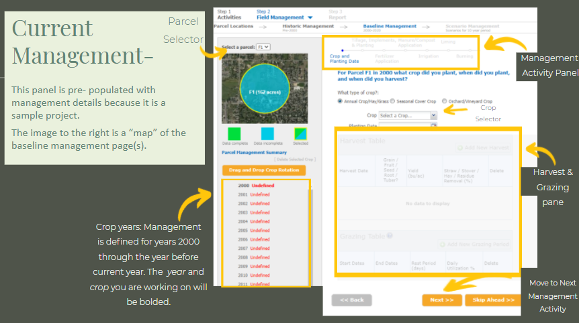
- Enter Baseline Management Details: Remember-COMET-Farm defines the baseline period as the “business as usual,” current management, or how the farm is currently being managed.
- Please review the “map” of the page below before proceeding to the next step. The management activity panel will tell you which step in the data entry you are working on for the year and crop selected.
  - If you have more than one parcel, use the Select a parcel drop down above the small map to toggle between parcels.
  - A small window will appear asking if you would like to create a crop rotation. This is the same window that will appear if you select the orange Drag and Drop Crop Rotation button just below the map.
    - The drag and drop crop rotation allows users to create a baseline that is populated with default values including average planting and harvest dates, yield, fertilizer dates and application rates, and irrigation amounts (if selected). Users do have the ability to modify any default values.
    - To use the drag and drop crop rotation, select the crop of choice from the images on the left, Drag the crop to the table on the right.
      - The water drop indicates the crop was irrigation. If no irrigation occurred, click the water drop and a red X will appear over it. You will have an opportunity later in the baseline to modify this again and add specific events.
      - Intensive tillage is automatically selected. To modify, select the tillage box and a dropdown menu will appear. Select the tillage implementation. Additional tillage implementations are offered on the tillage page with additional information for how COMET defines each type, so select the best option here and you can modify later.
      - Ex: If you have a 20 year corn-soybean rotation (like in the cropland demo), you will only need to drag 2 crops to the table:
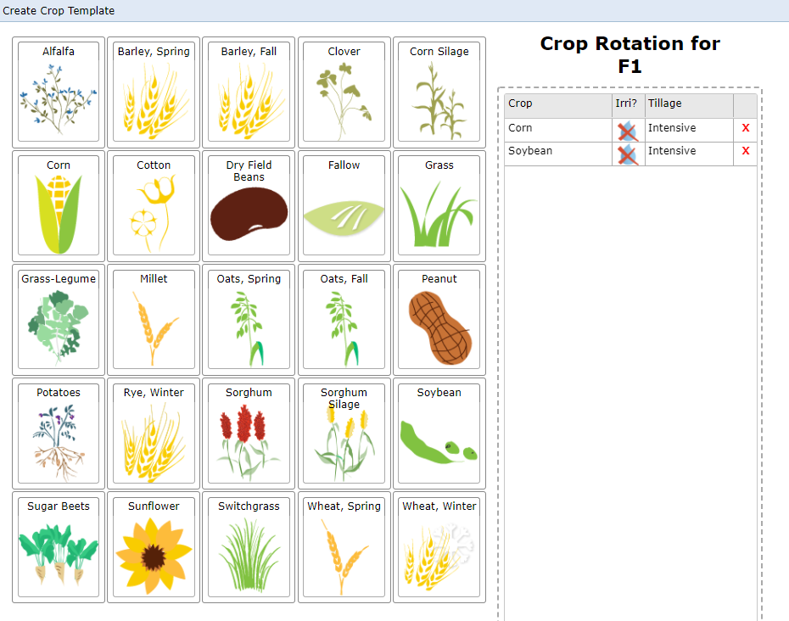
    - When you select Create Rotation Corn-Soybean, details will populate for the entire baseline period (just like the Cropland Demo Project).
Editing your baseline management choices OR adding a crop year by year (i.e. not using the Drag and Drop)- This would be the case if your crop does not appear in the Drag and Drop Crop Rotation crop list.
- Begin with the first year of the baseline period, 2000. The year and crop you are working on will be bolded in the pane on the left. Year 2000 should automatically be selected, but check to make sure.
- Adding your first crop:
  - Select which type of crop group your crop falls under: annual crop/hay/grass, seasonal cover crop, or orchard/vineyard
  - Using the crop selector drop down menu, select your first crop.
    - While over 30 crops are offered for accounting in COMET-Farm, you still may not see your crop. We may be able to offer a surrogate for crops you do not see that model similarly to available crops--for example: winter wheat as a surrogate for triticale. Use the Need help? Widget in the bottom left corner to contact the COMET support team for a potential surrogate crop.
    - Some crops are not supported by the COMET-Farm platform at this time. Users are unable to upload their own data to add a crop
- Select Add new harvest event in the harvest table.
  - Depending on the crop choice, default values may populate the cells for that harvest event. To modify any value, double click on the cell.
  - Importance of dates
- Addition of a grazing event
  - If you would like to add a grazing event, we would recommend also selecting Animal Agriculture as an accounting activity when on the project home page to report enteric emissions associated with housing and manure management of the animals.
- Select Next at the bottom. You should now be on the tillage implementation page.
- To add a tillage event, select +add tillage event.
  - Intensive tillage will automatically populate the cell. To modify, double click the tillage cell and select the tillage implementation that matches closest to your operation.
  - For an explanation of how COMET categorizes tillage passes, select the blue question mark at the top of the table. If you still can’t decide, you can send a message through the need help widget in the bottom right corner of the page.
  - Tillage dates: to modify the tillage implementation date, double click the small calendar icon and use the arrows to find your tillage date.
    - Important note- Tillage dates must occur at least the day of or day before planting OR after harvest. Any tillage events (intensive, reduced, ridge, strip, no till) dates entered between plant and harvest date will result in premature termination of the plant in the model (causing a change in the report).
      - If more than one tillage event occurs on the same day, please enter on sequential days. For example, if two strip till events occured on May 15th. Please enter one event on May 15th and one event on May 14th. The DayCent Model can only accommodate one event per day.
    - If you have multiple crops (max 3) in a year, ensure the planting, harvest, and tillage dates do not overlap. You should be flagged from proceeding to the future scenario if this is the case.
- Select next to proceed to the fertilizer application panel.
  - To add a fertilizer event, select +add fertilizer application
  - To modify the fertilizer application date, double click the small calendar icon and use the arrows to find your fertilizer date.
  - To modify the fertilizer type, double click the type cell and select from the dropdown menu
    - If you do not see your fertilizer type, you can select elemental N and add in the total N applied.
  - Depending on your fertilizer choice, default values will populate automatically. To modify these parameters, double click on the cell.
  - Fertigation:
    - Currently, COMET does not have a simple way of adding in fertigation events. The recommended way of adding a fertigation event would be to add a fertilizer application event each time nitrogen was included in the irrigation water.
    - Ex: If 20lbs N/acre/crop was incorporated in the irrigation water in 20 applications over the growing season, you should have 20 smaller fertilizer events on different days.
  - *Multiple fertilizer events same day* : If you have multiple events on the same day you have two options:
    - Option 1: Enter mixed blends as fertilizer type and combine total N and total P for all types
    - Option 2: Enter sequential dates for each fertilizer type. For example, if two fertilizer events occured on May 15th. Please enter one event on May 15th and one event on May 14th. The DayCent Model can only accommodate one event per day.
- Select next to proceed to the manure/compost panel.
  - To add a manure/compost event, select +add manure/compost
  - To modify the manure/compost application date, double click the small calendar icon and use the arrows to find your manure/compost date.
  - To modify the manure type, double click the type cell and select from the dropdown menu
    - If you do not see your fertilizer type, you can select other manure and add in the total N applied.
  - Depending on your manure/compost choice, default values (including C:N ratio) will populate automatically. To modify these parameters, double click on the cell.
- Select next to proceed to the irrigation panel.
  - COMET does not currently take methods of irrigation application (furrow, flood, drip, etc…) into account, but requires dates and amounts applied.
  - To add an irrigation event, select +add new irrigation application practice.
  - To modify the irrigation application date, double click the small calendar icon and use the arrows to find your irrigation date.
- Select next to proceed to the liming panel
  - To add a liming event, use the drop down menu to select lime type. After type is selected, you will then be able to select the date applied and add the amount applied.
  - For no liming event, keep the drop down menu set to none.
- Select next to proceed to the burning panel.
  - To add a burning event, use the drop down menu to select the date of event.
  - For no burning event, keep the drop down menu set to none.
- You have now completed the data entry for your first crop in your first year of the baseline. Select next to proceed.
- A window will appear asking if you would like to add an additional crop for the same year (max 3).
  - If you would like to add an additional crop, select yes, add an additional crop for the same year.
    - You will repeat steps 9-19.
  - If not, select No thanks, continue>>
- A copy window will appear. The current year and parcel you are working on will be selected with a green check mark. If the project had more than one parcel, the additional parcel(s) years would appear below the first parcel you created. Years highlighted with a red background indicate that management details have already been entered for that year.
  - If you used the Drag and Drop Crop Rotation, then each year will have a red outline around the box. This does not mean you cannot copy details from one year to the next, but make note of what you are copying.
    - If you are adding crops year by year and began with Year 2000, no red outlines should appear.
  - The Copy function minimizes the data entry load for users if multiple years follow the same or similar management practices, allowing the user to enter the details for one parcel/year and copy to other parcels/years. If there is only a slight change in management practices between two years, it may be beneficial to copy the information from one year to a single other year, then make the necessary adjustments. Then, repeat the copy function to any subsequent years with the same management.
  - To copy information from one parcel/year to another: check the boxes for the corresponding parcels/years you would like to copy the data to.
  - If you do not want to copy management details, select, No thanks, continue>>.
    - To finish entering baseline details, select the next undefined crop year in the grey pane to the left. Repeat steps 9-21 until all baseline years are populated with at least one crop.
    - Remember: If you have more than one parcel, use the Select a parcel drop down above the small map to toggle between parcels and repeat steps 7-21 as needed.
    - You cannot proceed to the future scenario if your baseline for all parcels and all years is incomplete.
- When you are done defining the baseline management of your parcel(s) select continue to future management.
- Enter Future Management Details: COMET-Farm defines the Scenario (future) Period as the 10 years after the end of the baseline. In your project, because the baseline period ends in 2020, the future scenario(s) will be from 2021-2030.
  - COMET-Farm allows for a maximum of 10 scenarios. It is important to note, the more complex a project (higher amount of parcels, high acreage, or more scenarios), the longer a report may take to generate.
- A small window will appear where you will name your first scenario.
  - We would recommend a short (25 characters), descriptive title. This will help when interpreting reports.
  - If making small changes to the future scenario (ex. reducing N content in fertilizer applications or switching from intensive to no till), select the box Copy management information from my Current Management to minimize the data entry process for the future scenario.
      - If you would like to start from scratch for your future scenario, Add the descriptive title and select Start or Create new scenario.
      - Drag and Drop Crop rotation button allows you to create a new crop rotation for this scenario.
      - Add Conservation Practice is a quick way to add a cover crop or reduce tillage.
        - These are not the only conservation practices that can be implemented. They are simply a quick way to make a simple change. Users can modify any part of the future scenario just like they entered details in the baseline.
    - Select start>>.
- If you copied the management information from your baseline to the future scenario, your future scenario will now look identical to the baseline scenario EXCEPT the years now span 2021-2030 until you make changes.
- The year/crop management details you are currently viewing (and can modify) will be bolded in the activity years on the left.
- Management details can be added, modified, or deleted in the exact same manner as the baseline management you completed in steps 7-21.
  - Note: when the copy box appears, all parcels/years will have a red box because you copied all data from the baseline. If you made changes to any of the years, you can overwrite the management currency in that year/parcel by copying details.
- When you have selected either No, thanks or Copy and Continue on the Copy Window, we would recommend selecting keep editing, just to check over your first future scenario.
- When you have completed modifying and checking all parcels/years for your first scenario, select skip ahead. Select No thanks for adding an additional crop AND copying data.
  - A window will appear asking if you would like to Continue to the report, add another scenario, or keep editing.
    - Create a new scenario- Each project can accommodate up to 10 future scenarios. You can also add a new scenario by selecting [new] next to the selected scenario above the small map.
      - If you have more than one scenario, you can only proceed to the report if all years and parcels in all scenarios are completed with at least a crop planting and harvest/termination date.
    - Keep editing if you need to review your changes
- You will be taken to the report page. This can take a few minutes with a high volume of users sending reports at the same time. If you have created an account, you can navigate away from the browser and the system will continue to execute the models to run your report.
- For a detailed breakdown of the report, please view this FAQ page.

